**Name: SAURABH SHEKHAR PISAL CWID: A20403781**

Table of Contents

PHASE 5: Review of Current Project Status 3

PHASE 6: Designing the Physical Application 3

ERD 3

DATABASE TABLE CREATION 4

SCREENSHOTS. 4

CODE: 6

PHASE 7: LOADING DATA WITH VALID DATA 8

DATABASE TABLE DATA INSERTION 8

SCREENSHOTS. 8

PHASE 8: TESTING THE DATABASE SYSTEM 15

QUERIES: 15

DATA ANALYTICAL QUERIES SCREENSHOTS: 15

CODE: 22

DATABASE INTEGRITY VALIDATION AND ANOMOLIES: 24

SUCCESSFUL VALIDATION: 27

PHASE 9: DATA ANALYTICS PERFORMED 30

Web Presence for Your Application Screenshots 31

Output Calculation: 32

Error Trapping 32

Code: 34

PHASE 10: Systems Analysis and Viewpoints 39

Business Intelligence 39

Data Gravity 39

Data Management 39

Data Mining 39

Data Science 39

Predictive Analytics 40

# PHASE 5: Review of Current Project Status

The current project has come to a conclusion where the Database logical models have finally come to their physical state and data has been added to it for the customer. I.e. For Mani’s Magazine.

The database project for the Magazine store has been complete tested and verified for all its validations and now can be successfully implemented on the production environment and good to use.

# PHASE 6: Designing the Physical Application

## ERD

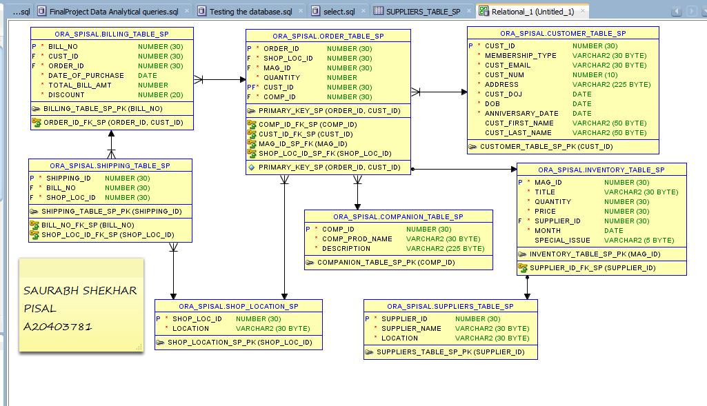

## DATABASE TABLE CREATION

### SCREENSHOTS.

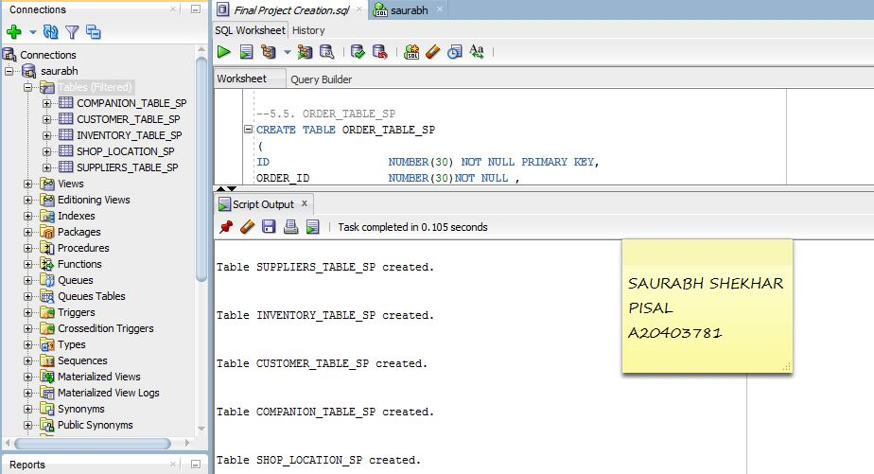

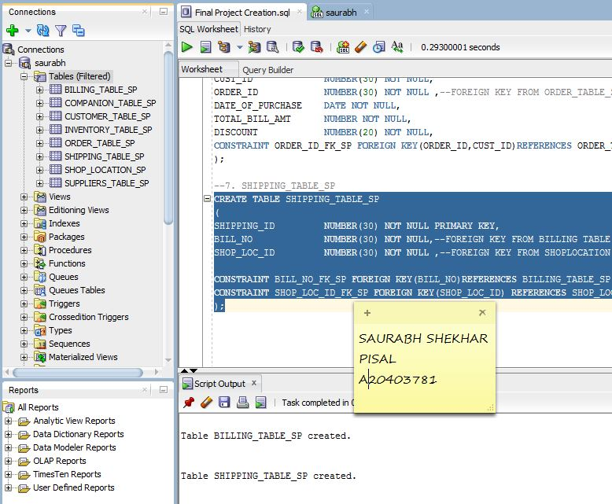

### CODE:

-- 1. SUPPLIERS_TABLE_SP DONE

CREATE TABLE SUPPLIERS_TABLE_SP

(

SUPPLIER_ID NUMBER(30) NOT NULL PRIMARY KEY,

SUPPLIER_NAME VARCHAR2(30)NOT NULL,

LOCATION VARCHAR2(30)NOT NULL

);

-- 2. INVENTORY_TABLE_SP DONE

CREATE TABLE INVENTORY_TABLE_SP

(

MAG_ID NUMBER(30) NOT NULL PRIMARY KEY,

TITLE VARCHAR2(30)NOT NULL,

QUANTITY NUMBER(30)NOT NULL,

PRICE NUMBER(30)NOT NULL,

SUPPLIER_ID NUMBER(30)NOT NULL, --FOREIGN KEY FROM SUPPLIERS_TABLE_SP

MONTH DATE NOT NULL,

SPECIAL_ISSUE VARCHAR2(5) CHECK(SPECIAL_ISSUE='YES' OR SPECIAL_ISSUE='NO'),

CONSTRAINT SUPPLIER_ID_FK_SP FOREIGN KEY(SUPPLIER_ID) REFERENCES SUPPLIERS_TABLE_SP(SUPPLIER_ID)

);

-- 3. CUSTOMER_TABLE_SP DONE

CREATE TABLE CUSTOMER_TABLE_SP

(

CUST_ID NUMBER(30) NOT NULL PRIMARY KEY,

MEMBERSHIP_TYPE VARCHAR2(30)NOT NULL,

CUST_EMAIL VARCHAR2(30)NOT NULL,

CUST_NUM NUMBER(10) NOT NULL,

ADDRESS VARCHAR2(225) NOT NULL,

CUST_DOJ DATE NOT NULL,

DOB DATE NOT NULL,

ANNIVERSARY_DATE DATE NOT NULL

);

-- 4. COMPANION_TABLE_SP DONE

CREATE TABLE COMPANION_TABLE_SP

(

COMP_ID NUMBER(30) NOT NULL PRIMARY KEY,

COMP_PROD_NAME VARCHAR2(30)NOT NULL,

DESCRIPTION VARCHAR2(225)NOT NULL

);

-- 5. SHOP_LOCATION_SP DONE

CREATE TABLE SHOP_LOCATION_SP

(

SHOP_LOC_ID NUMBER(30) NOT NULL PRIMARY KEY,

LOCATION VARCHAR2(30)NOT NULL

);

--5.5. ORDER_TABLE_SP DONE

--DROP TABLE ORDER_TABLE_SP

CREATE TABLE ORDER_TABLE_SP

(

--ID NUMBER(30) NOT NULL PRIMARY KEY,

ORDER_ID NUMBER(30)NOT NULL ,

SHOP_LOC_ID NUMBER(30)NOT NULL, -- FOREGIN KEY FROM SHOP_LOCATION_SP TABLE

MAG_ID NUMBER(30) NOT NULL,-- FOREIGN KEY FROM INENTORY_TABLE_SP

QUANTITY NUMBER NOT NULL,

CUST_ID NUMBER(30) NOT NULL ,--FOREIGN KEY FROM CUSTOMER_TABLE_SP

COMP_ID NUMBER(30) NOT NULL,--FOREIGN KEY FROM COMPANION_TABLE_SP

CONSTRAINT PRIMARY_KEY_SP PRIMARY KEY(ORDER_ID,CUST_ID),

CONSTRAINT SHOP_LOC_ID_SP_FK FOREIGN KEY(SHOP_LOC_ID) REFERENCES SHOP_LOCATION_SP(SHOP_LOC_ID),

CONSTRAINT MAG_ID_SP_FK FOREIGN KEY(MAG_ID) REFERENCES INVENTORY_TABLE_SP(MAG_ID),

CONSTRAINT CUST_ID_FK_SP FOREIGN KEY(CUST_ID) REFERENCES CUSTOMER_TABLE_SP(CUST_ID),

CONSTRAINT COMP_ID_FK_SP FOREIGN KEY(COMP_ID)REFERENCES COMPANION_TABLE_SP(COMP_ID)

);

-- 6. BILLING_TABLE_SP DONE

CREATE TABLE BILLING_TABLE_SP

(

BILL_NO NUMBER(30) NOT NULL PRIMARY KEY,

CUST_ID NUMBER(30) NOT NULL,

ORDER_ID NUMBER(30) NOT NULL ,--FOREIGN KEY FROM ORDER_TABLE_SP

DATE_OF_PURCHASE DATE NOT NULL,

TOTAL_BILL_AMT NUMBER NOT NULL,

DISCOUNT NUMBER(20) NOT NULL,

CONSTRAINT ORDER_ID_FK_SP FOREIGN KEY(ORDER_ID,CUST_ID)REFERENCES ORDER_TABLE_SP(ORDER_ID,CUST_ID)

);

--7. SHIPPING_TABLE_SP

CREATE TABLE SHIPPING_TABLE_SP

(

SHIPPING_ID NUMBER(30) NOT NULL PRIMARY KEY,

BILL_NO NUMBER(30) NOT NULL,--FOREIGN KEY FROM BILLING TABLE

SHOP_LOC_ID NUMBER(30) NOT NULL ,--FOREIGN KEY FROM SHOPLOCATION TABLE

CONSTRAINT BILL_NO_FK_SP FOREIGN KEY(BILL_NO)REFERENCES BILLING_TABLE_SP(BILL_NO),

CONSTRAINT SHOP_LOC_ID_FK_SP FOREIGN KEY(SHOP_LOC_ID) REFERENCES SHOP_LOCATION_SP(SHOP_LOC_ID)

);

# PHASE 7: LOADING DATA WITH VALID DATA

## DATABASE TABLE DATA INSERTION

### SCREENSHOTS.

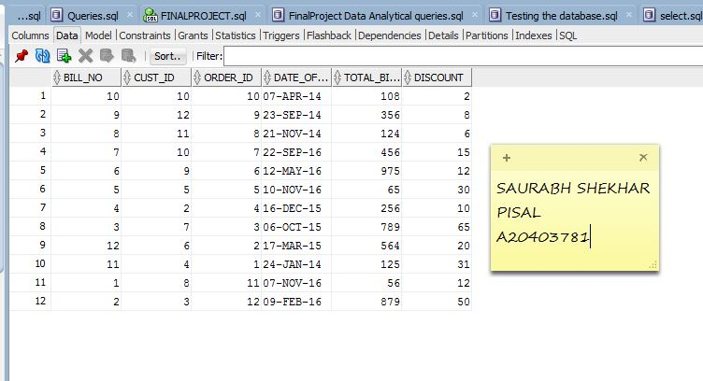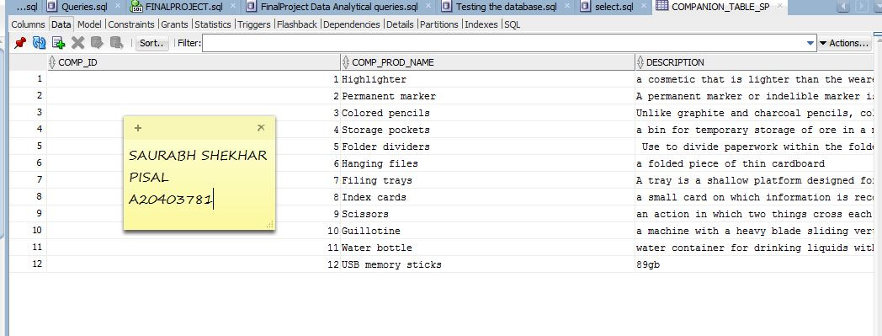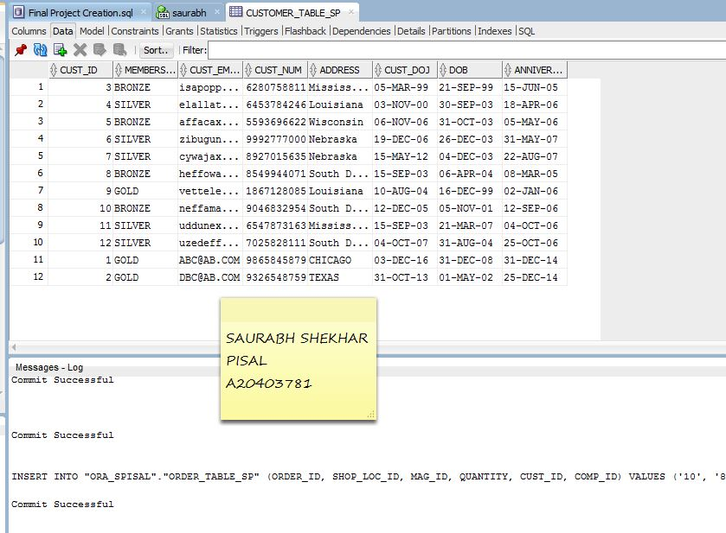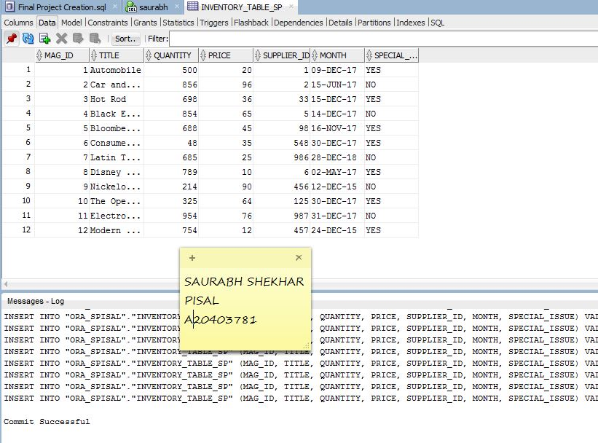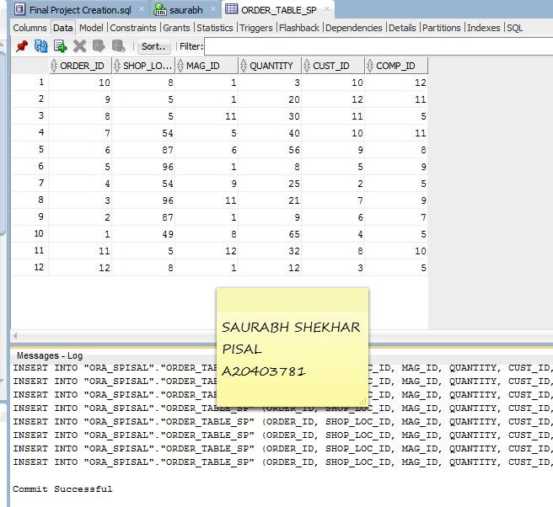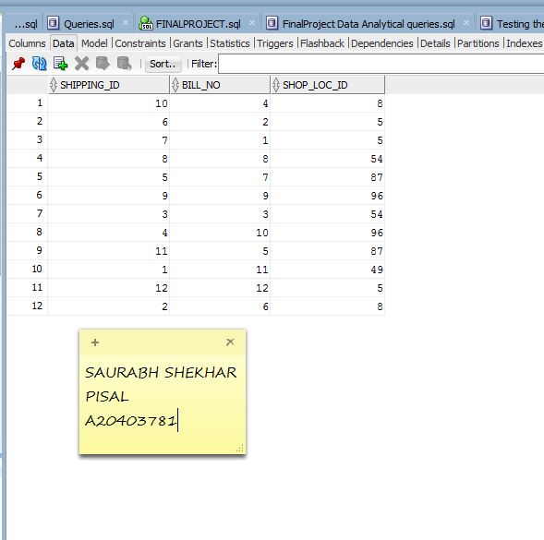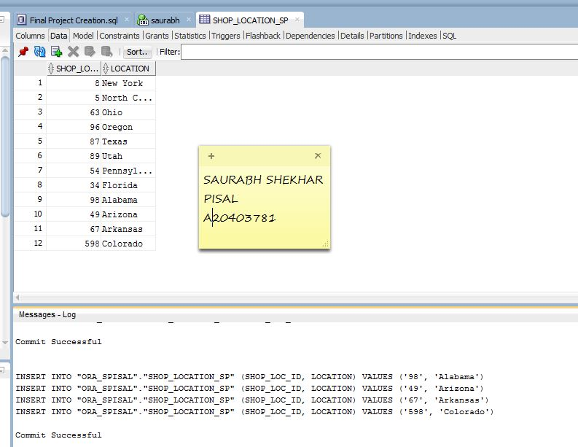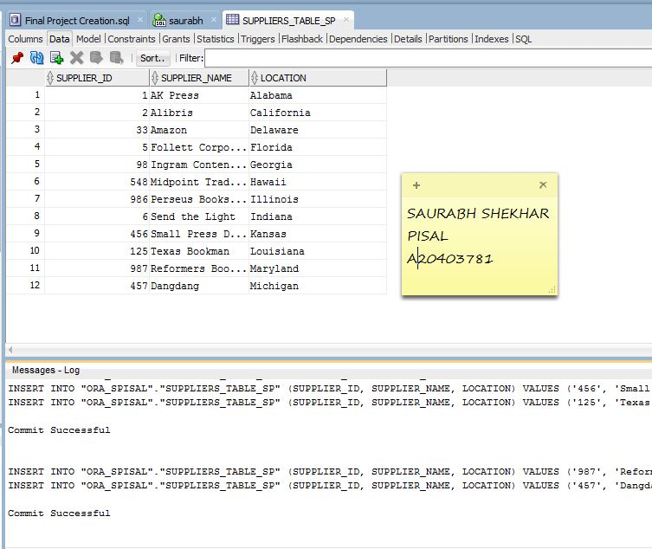

# PHASE 8: TESTING THE DATABASE SYSTEM

## QUERIES:

### DATA ANALYTICAL QUERIES SCREENSHOTS:

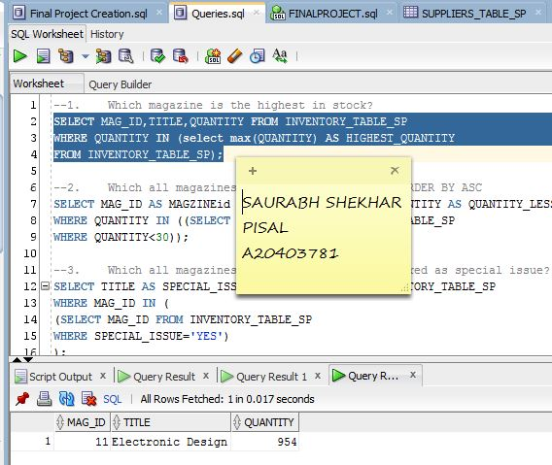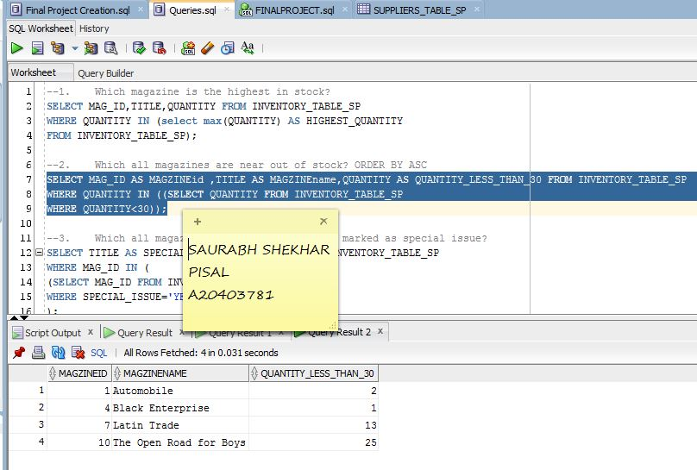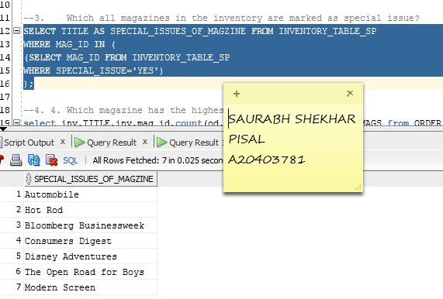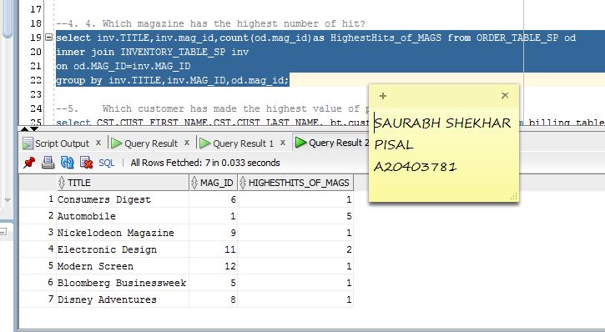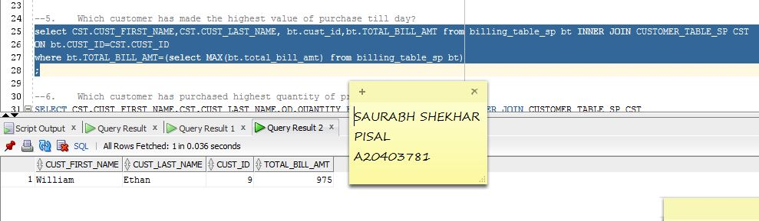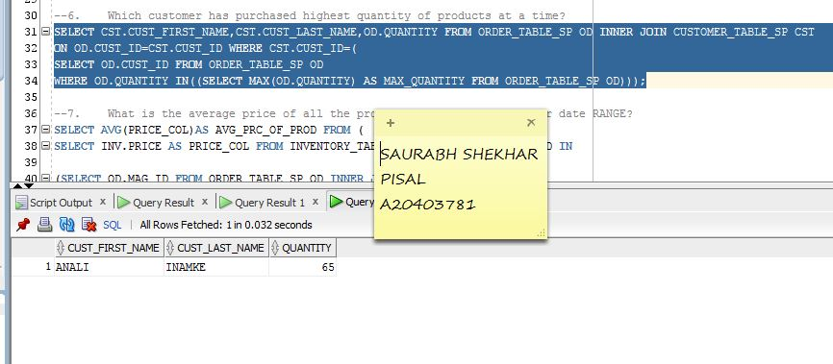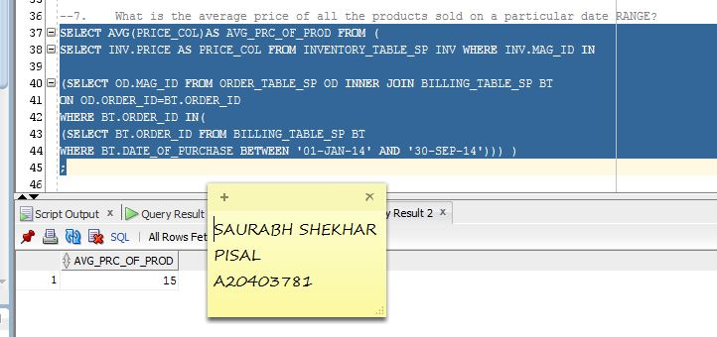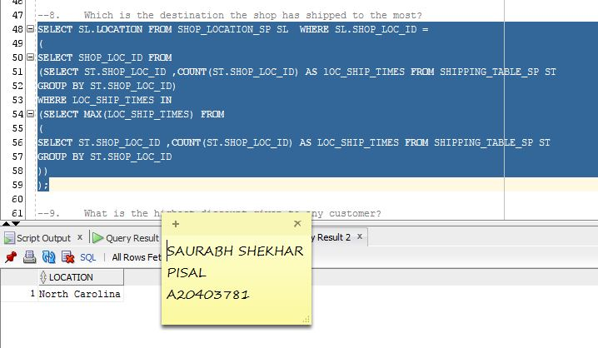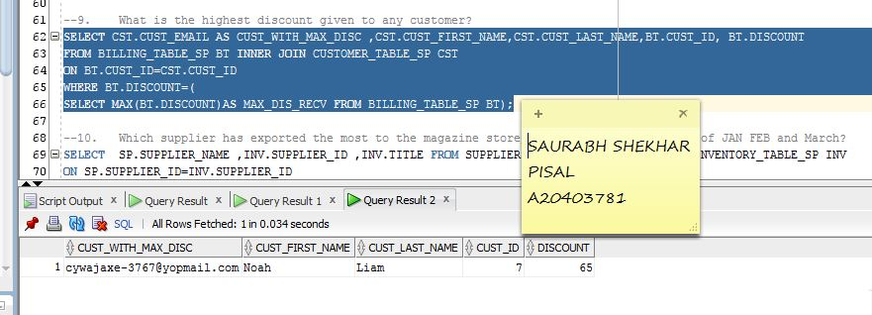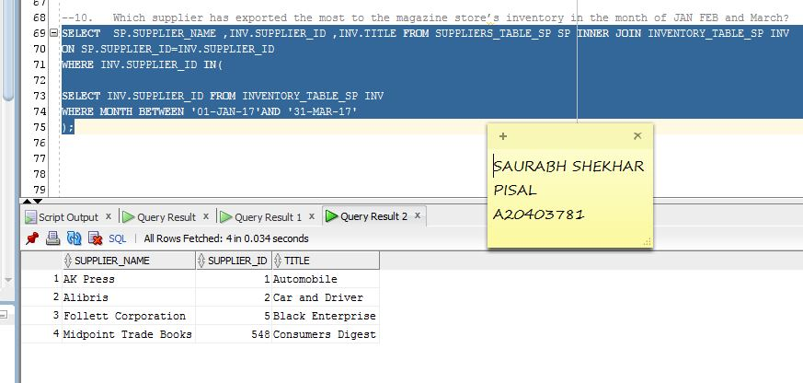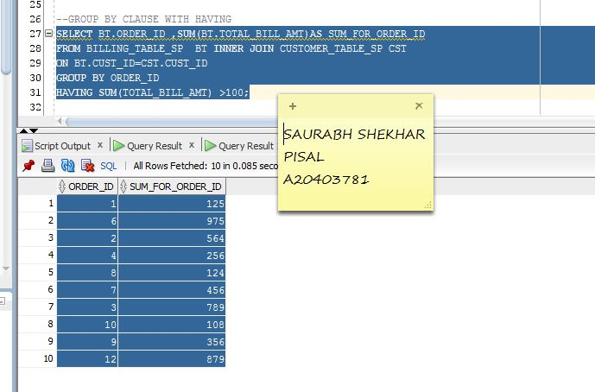

### CODE:

--1. Which magazine is the highest in stock?

SELECT MAG_ID,TITLE,QUANTITY FROM INVENTORY_TABLE_SP

WHERE QUANTITY IN (select max(QUANTITY) AS HIGHEST_QUANTITY

FROM INVENTORY_TABLE_SP);

--2. Which all magazines are near out of stock? ORDER BY ASC

SELECT MAG_ID AS MAGZINEid ,TITLE AS MAGZINEname,QUANTITY AS QUANTITY_LESS_THAN_30 FROM INVENTORY_TABLE_SP

WHERE QUANTITY IN ((SELECT QUANTITY FROM INVENTORY_TABLE_SP

WHERE QUANTITY<30));

--3. Which all magazines in the inventory are marked as special issue?

SELECT TITLE AS SPECIAL_ISSUES_OF_MAGZINE FROM INVENTORY_TABLE_SP

WHERE MAG_ID IN (

(SELECT MAG_ID FROM INVENTORY_TABLE_SP

WHERE SPECIAL_ISSUE='YES')

);

--4. Which magazine has the highest number of hit?

select inv.TITLE,inv.mag_id,count(od.mag_id)as HighestHits_of_MAGS from ORDER_TABLE_SP od

inner join INVENTORY_TABLE_SP inv

on od.MAG_ID=inv.MAG_ID

group by inv.TITLE,inv.MAG_ID,od.mag_id;

--5. Which customer has made the highest value of purchase till day?

select CST.CUST_FIRST_NAME,CST.CUST_LAST_NAME, bt.cust_id,bt.TOTAL_BILL_AMT from billing_table_sp bt INNER JOIN CUSTOMER_TABLE_SP CST

ON bt.CUST_ID=CST.CUST_ID

where bt.TOTAL_BILL_AMT=(select MAX(bt.total_bill_amt) from billing_table_sp bt)

;

--6. Which customer has purchased highest quantity of products at a time?

SELECT CST.CUST_FIRST_NAME,CST.CUST_LAST_NAME,OD.QUANTITY FROM ORDER_TABLE_SP OD INNER JOIN CUSTOMER_TABLE_SP CST

ON OD.CUST_ID=CST.CUST_ID WHERE CST.CUST_ID=(

SELECT OD.CUST_ID FROM ORDER_TABLE_SP OD

WHERE OD.QUANTITY IN((SELECT MAX(OD.QUANTITY) AS MAX_QUANTITY FROM ORDER_TABLE_SP OD)));

--7. What is the average price of all the products sold on a particular date RANGE?

SELECT AVG(PRICE_COL)AS AVG_PRC_OF_PROD FROM (

SELECT INV.PRICE AS PRICE_COL FROM INVENTORY_TABLE_SP INV WHERE INV.MAG_ID IN

(SELECT OD.MAG_ID FROM ORDER_TABLE_SP OD INNER JOIN BILLING_TABLE_SP BT

ON OD.ORDER_ID=BT.ORDER_ID

WHERE BT.ORDER_ID IN(

(SELECT BT.ORDER_ID FROM BILLING_TABLE_SP BT

WHERE BT.DATE_OF_PURCHASE BETWEEN '01-JAN-14' AND '30-SEP-14'))) )

;

--8. Which is the destination the shop has shipped to the most?

SELECT SL.LOCATION FROM SHOP_LOCATION_SP SL WHERE SL.SHOP_LOC_ID =

(

SELECT SHOP_LOC_ID FROM

(SELECT ST.SHOP_LOC_ID ,COUNT(ST.SHOP_LOC_ID) AS lOC_SHIP_TIMES FROM SHIPPING_TABLE_SP ST

GROUP BY ST.SHOP_LOC_ID)

WHERE LOC_SHIP_TIMES IN

(SELECT MAX(LOC_SHIP_TIMES) FROM

(

SELECT ST.SHOP_LOC_ID ,COUNT(ST.SHOP_LOC_ID) AS LOC_SHIP_TIMES FROM SHIPPING_TABLE_SP ST

GROUP BY ST.SHOP_LOC_ID

))

);

--9. What is the highest discount given to any customer?

SELECT CST.CUST_EMAIL AS CUST_WITH_MAX_DISC ,CST.CUST_FIRST_NAME,CST.CUST_LAST_NAME,BT.CUST_ID, BT.DISCOUNT

FROM BILLING_TABLE_SP BT INNER JOIN CUSTOMER_TABLE_SP CST

ON BT.CUST_ID=CST.CUST_ID

WHERE BT.DISCOUNT=(

SELECT MAX(BT.DISCOUNT)AS MAX_DIS_RECV FROM BILLING_TABLE_SP BT);

--10. Which supplier has exported the most to the magazine store’s inventory in the month of JAN FEB and March?

SELECT SP.SUPPLIER_NAME ,INV.SUPPLIER_ID ,INV.TITLE FROM SUPPLIERS_TABLE_SP SP INNER JOIN INVENTORY_TABLE_SP INV

ON SP.SUPPLIER_ID=INV.SUPPLIER_ID

WHERE INV.SUPPLIER_ID IN(

SELECT INV.SUPPLIER_ID FROM INVENTORY_TABLE_SP INV

WHERE MONTH BETWEEN '01-JAN-17'AND '31-MAR-17'

);

--11. GROUP BY CLAUSE WITH HAVING

SELECT BT.ORDER_ID ,SUM(BT.TOTAL_BILL_AMT)AS SUM_FOR_ORDER_ID

FROM BILLING_TABLE_SP BT INNER JOIN CUSTOMER_TABLE_SP CST

ON BT.CUST_ID=CST.CUST_ID

GROUP BY ORDER_ID

HAVING SUM(TOTAL_BILL_AMT) >100;

### DATABASE INTEGRITY VALIDATION AND ANOMOLIES:

#### SCREENSHOTS:

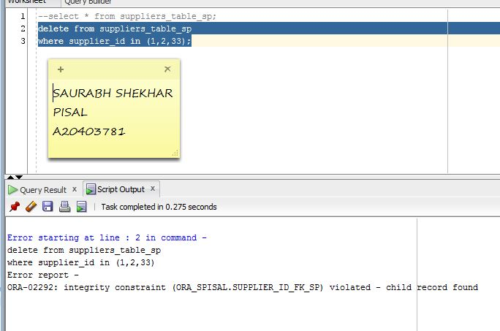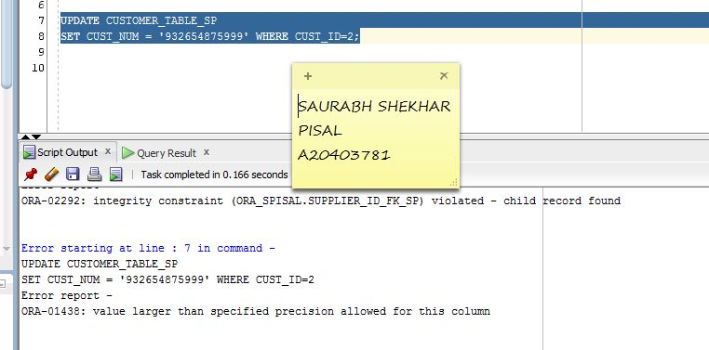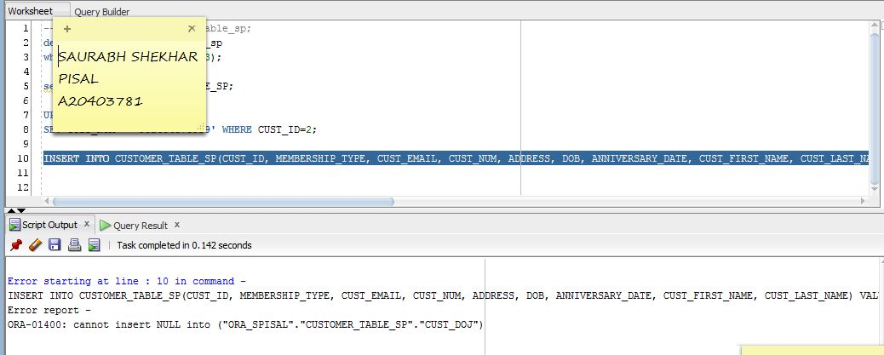

#### CODE:

-- 1. INTEGRITY ISSUE

--select * from suppliers_table_sp;

delete from suppliers_table_sp

where supplier_id in (1,2,33);

--2. UPDATE

UPDATE CUSTOMER_TABLE_SP

SET CUST_NUM = '932654875999' WHERE CUST_ID=2;

--3. INSERT

INSERT INTO CUSTOMER_TABLE_SP(CUST_ID, MEMBERSHIP_TYPE, CUST_EMAIL, CUST_NUM, ADDRESS, DOB, ANNIVERSARY_DATE, CUST_FIRST_NAME, CUST_LAST_NAME) VALUES ('15', 'GOLD', 'GOLD@ABC', '1010101010', 'ABC', TO_DATE('2002-05-01 00:00:00', 'YYYY-MM-DD HH24:MI:SS'), TO_DATE('2014-12-25 00:00:00', 'YYYY-MM-DD HH24:MI:SS'), 'ABC', 'ABC');

### SUCCESSFUL VALIDATION:

#### SCREENSHOTS:

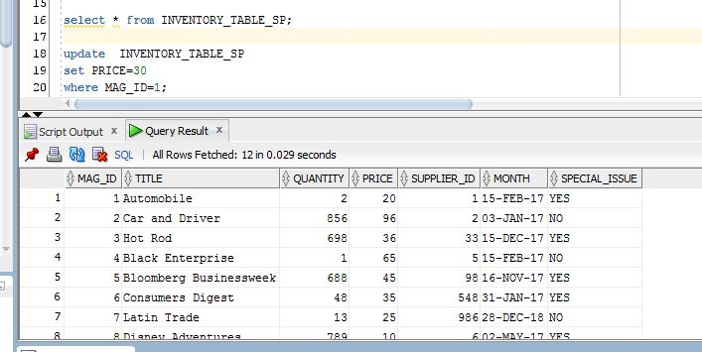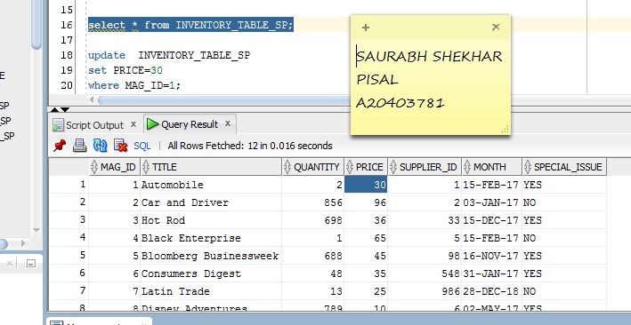

BEFORE INSERTION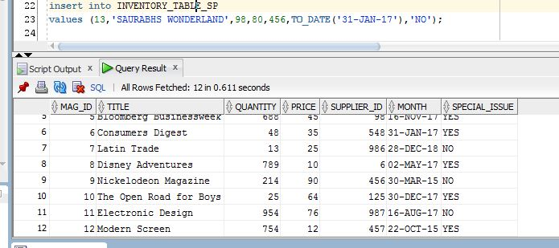

AFTER INSERTION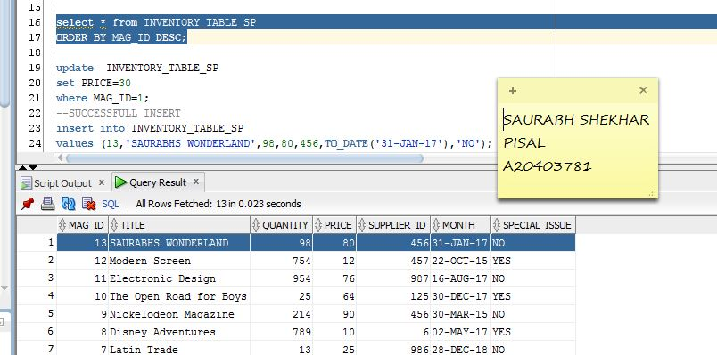

#### CODE:

--successful testing of database

--1. update

select * from INVENTORY_TABLE_SP

ORDER BY MAG_ID DESC;

update INVENTORY_TABLE_SP

set PRICE=30

where MAG_ID=1;

--2. SUCCESSFULL INSERT

insert into INVENTORY_TABLE_SP

values (13,'SAURABHS WONDERLAND',98,80,456,TO_DATE('31-JAN-17'),'NO');

# PHASE 9: DATA ANALYTICS PERFORMED

Data analytics has been performed on 2 tables.

1. INVENTORY

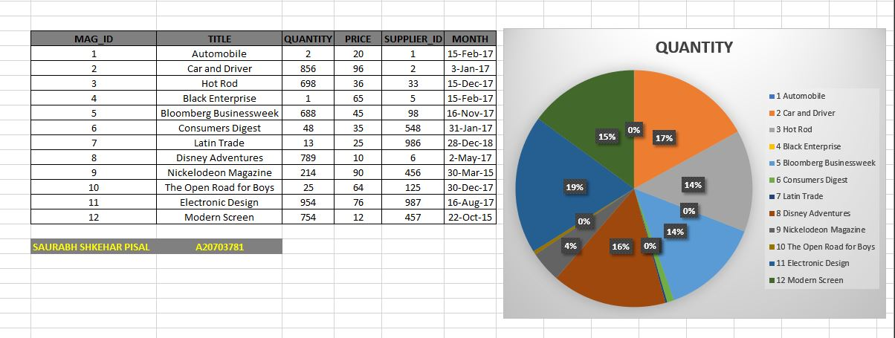

1. CUSTOMER TABE

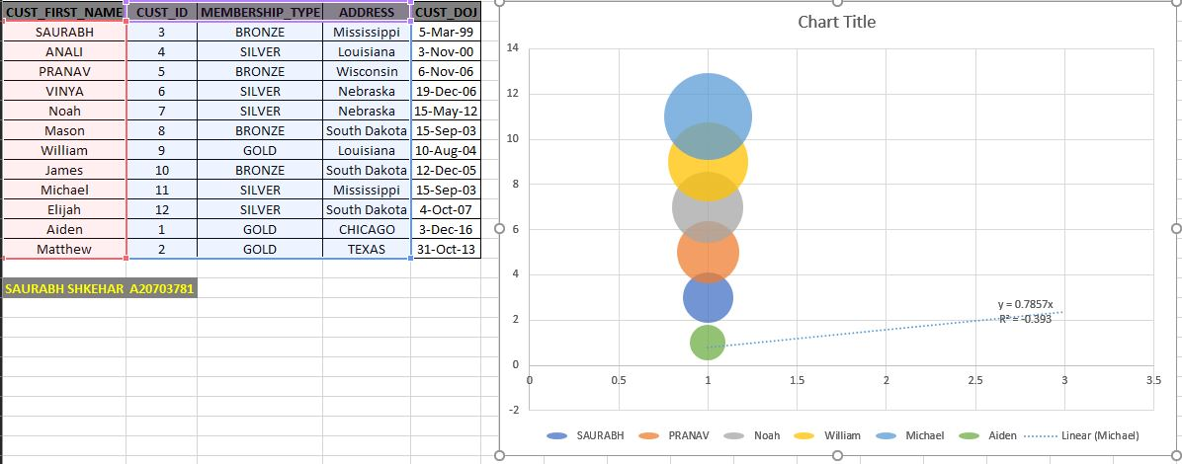

# Web Presence for Your Application Screenshots

Username: Saurabh Password: Saurabh@123

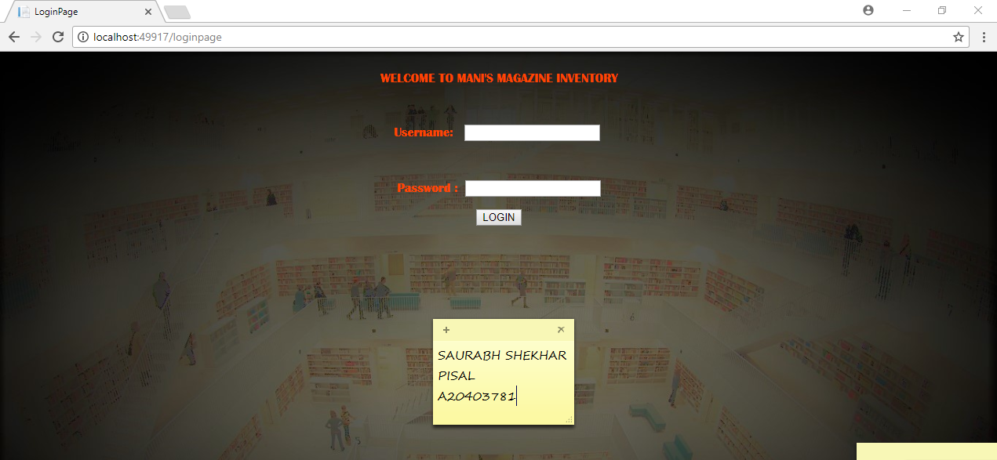

2nd form

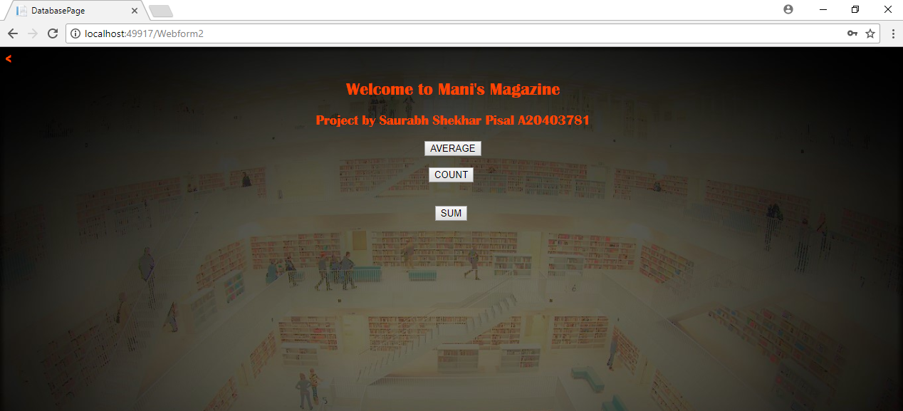

### Output Calculation:

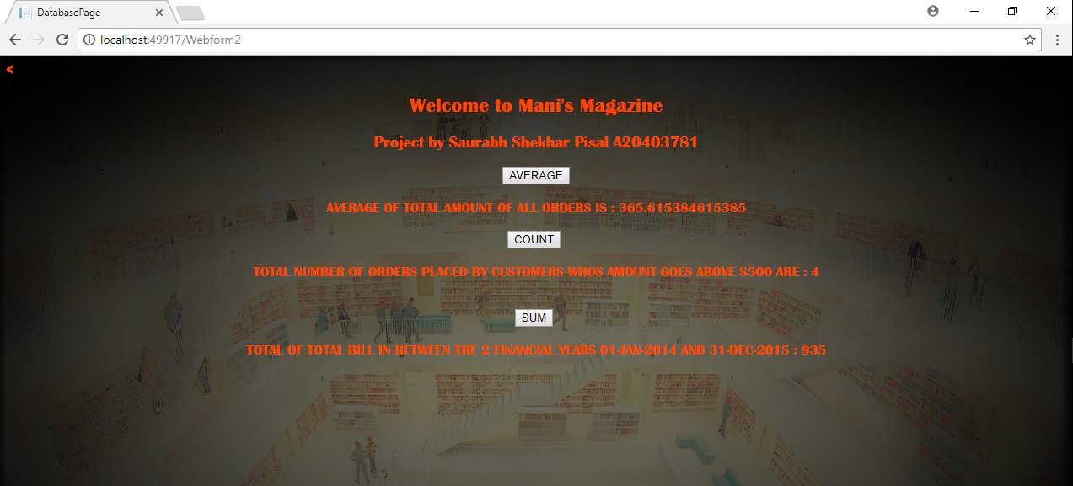

### Error Trapping

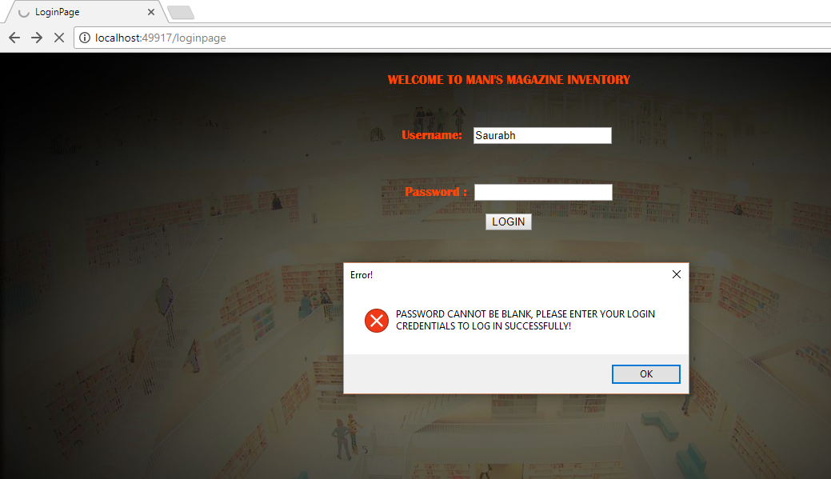

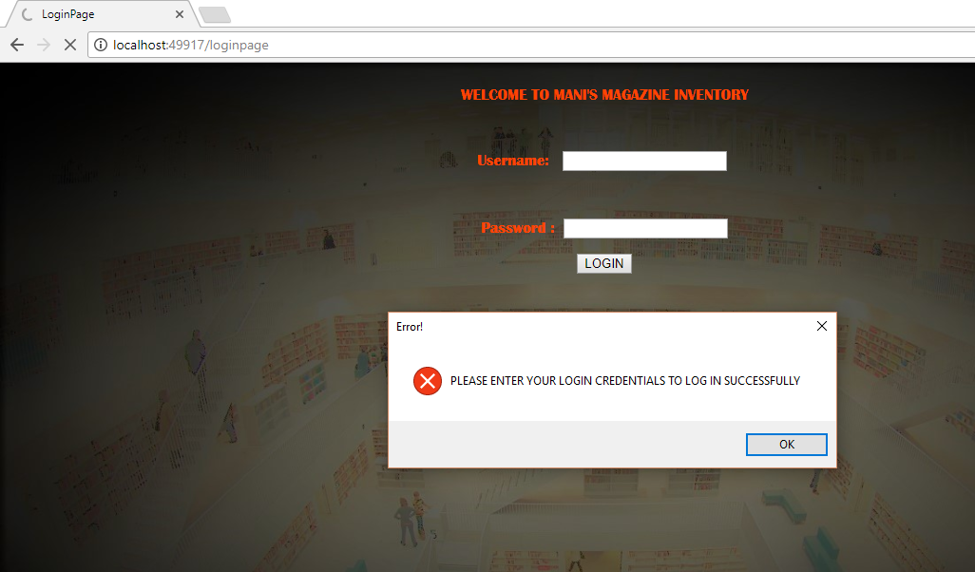

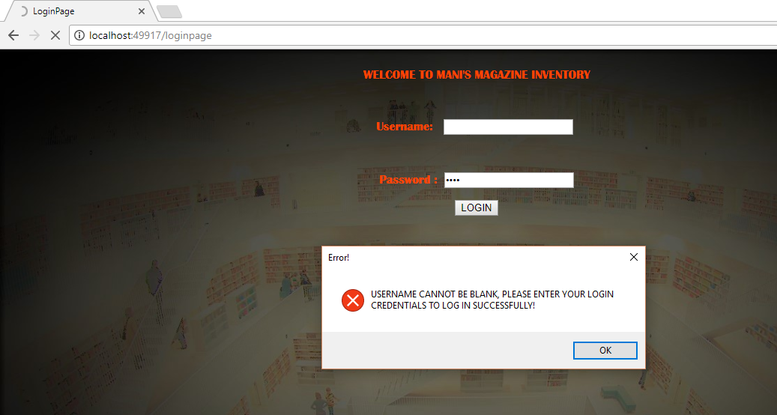

### Code:

Login page code

<%@ Page Language="VB" %>

<!DOCTYPE html>

<script runat="server">

Protected Sub TextBox1_TextChanged(spSNDR As Object, spEvnt As EventArgs)

End Sub

Protected Sub Button1_Click(spSNDR As Object, spEvnt As EventArgs)

End Sub

Protected Sub Button2_Click(spSNDR As Object, spEvnt As EventArgs)

If USERNAME.Text = "Saurabh" And PASSWORD.Text = "Saurabh@123" Then

Response.Redirect("Webform2.aspx")

Else

If USERNAME.Text = "" And PASSWORD.Text = "" Then

MsgBox("PLEASE ENTER YOUR LOGIN CREDENTIALS TO LOG IN SUCCESSFULLY", MsgBoxStyle.Critical, "Error!")

Else

If USERNAME.Text = "" Then

MsgBox("USERNAME CANNOT BE BLANK, PLEASE ENTER YOUR LOGIN CREDENTIALS TO LOG IN SUCCESSFULLY!", MsgBoxStyle.Critical, "Error!")

Else

If PASSWORD.Text = "" Then

MsgBox("PASSWORD CANNOT BE BLANK, PLEASE ENTER YOUR LOGIN CREDENTIALS TO LOG IN SUCCESSFULLY!", MsgBoxStyle.Critical, "Error!")

Else

MsgBox("INVALID CREDENTIALS, PLEASE CHECK AND LOGIN AGAIN!", MsgBoxStyle.Critical, "Error!")

End If

End If

End If

End If

End Sub

</script>

<html xmlns="http://www.w3.org/1999/xhtml">

<head runat="server">

<title>LoginPage</title>

</head>

<center>

<body style = "font-family:Britannic;background-image: url(Image2.jpg); background-size: cover;color:orangered">

<form id="form1" runat="server">

<div>

<br />

WELCOME TO MANI&#39;S MAGAZINE INVENTORY<br />

<br />

<br />

<br />

Username:<asp:TextBox ID="USERNAME" runat="server" OnTextChanged="TextBox1_TextChanged" style="margin-left: 15px"></asp:TextBox>

<br />

<br />

<br />

</div>

<p>

Password :&nbsp;

<asp:TextBox ID="PASSWORD" runat="server" TextMode="Password"></asp:TextBox>

</p>

<p>

</p>

<p>

</p>

</p>

<asp:Button ID="Button2" runat="server" OnClick="Button2_Click" Text="LOGIN" />

</form>

</center>

</body>

</html>

Webform2 code:

<<%@ Page Language = "VB" %>

<%@ Import Namespace = "System.Data.OleDb" %>

<%@ Import Namespace = "System.IO" %>

<%@ Import Namespace = "System.Drawing" %>

<!DOCTYPE html>

<html xmlns = "http://www.w3.org/1999/xhtml">

<head id = "Head1" runat = "server">

<title>DatabasePage</title>

<script runat = "server">

Public Class PictureBox

Property Image As Drawing.Bitmap

End Class

Sub average(spexp As Object, evnt_sp As EventArgs)

Try

'Connect to the Database

Dim spAccess As New OleDbConnection(

"Provider = Microsoft.Jet.OLEDB.4.0;" &

"Data Source = C:\Users\Saurabh\OneDrive - hawk.iit.edu\sEM 1\Adv topics in Datamanagement\Final Projecct\FinalProject.mdb")

spAccess.Open()

'Construct the SELECT statement

Dim spresltst As String

'Create the SQL Select Statement

spresltst = "SELECT AVG(TOTAL_BILL_AMT) FROM BILLING_TABLE_SP"

'Create the OleDbCommand object

Dim spSlct As New OleDbCommand(spresltst, spAccess)

Dim spReader As OleDbDataReader, sbResults As New StringBuilder()

spReader = spSlct.ExecuteReader()

sbResults.Append("<table>")

While spReader.Read()

sbResults.Append("<tr><td>")

sbResults.Append("AVERAGE OF TOTAL AMOUNT OF ALL ORDERS IS : " + spReader.GetValue(0).ToString)

sbResults.Append("</tr></td>")

sbResults.Append("</tr></td>")

End While

sbResults.Append("</table>")

click.Text = sbResults.ToString()

spAccess.Close()

spAccess = Nothing

Catch ex As Exception

Response.Write(ex.Message)

Response.Write("<<<<<<<<<< CONNECTION HAS FAILED >>>>>>>>>>")

End Try

End Sub

Sub count(spexp As Object, evnt_sp As EventArgs)

Try

'Connect to the Database

Dim spAccess As New OleDbConnection(

"Provider = Microsoft.Jet.OLEDB.4.0;" &

"Data Source = C:\Users\Saurabh\OneDrive - hawk.iit.edu\sEM 1\Adv topics in Datamanagement\Final Projecct\FinalProject.mdb")

spAccess.Open()

'Construct the SELECT statement

Dim sSel As String

'Create the SQL Select Statement

sSel = "SELECT Count(*) FROM BILLING_TABLE_SP WHERE TOTAL_BILL_AMT >= 500"

'Create the OleDbCommand object

Dim spSlct As New OleDbCommand(sSel, spAccess)

Dim spReader As OleDbDataReader, sbResults As New StringBuilder()

spReader = spSlct.ExecuteReader()

sbResults.Append("<table>")

While spReader.Read()

sbResults.Append("<tr><td>")

sbResults.Append("TOTAL NUMBER OF ORDERS PLACED BY CUSTOMERS WHOS AMOUNT GOES ABOVE $500 ARE : " + spReader.GetValue(0).ToString

)

sbResults.Append("</tr></td>")

End While

sbResults.Append("</table>")

click1.Text = sbResults.ToString()

spAccess.Close()

spAccess = Nothing

Catch ex As Exception

Response.Write(ex.Message)

Response.Write("<<<<< CONNECTION HAS FAILED >>>>>")

End Try

End Sub

Sub sum(spexp As Object, evnt_sp As EventArgs)

Try

'Connect to the Database

Dim spAccess As New OleDbConnection(

"Provider = Microsoft.Jet.OLEDB.4.0;" &

"Data Source = C:\Users\Saurabh\OneDrive - hawk.iit.edu\sEM 1\Adv topics in Datamanagement\Final Projecct\FinalProject.mdb")

spAccess.Open()

'Construct the SELECT statement

Dim vSel As String

'Create the SQL Select Statement

vSel = "SELECT SUM(TOTAL_BILL_AMT) FROM BILLING_TABLE_SP WHERE BILL_NO BETWEEN 1 AND 2"

'Create the OleDbCommand object

Dim spSlct As New OleDbCommand(vSel, spAccess)

Dim spReader As OleDbDataReader, sbResults As New StringBuilder()

spReader = spSlct.ExecuteReader()

sbResults.Append("<table>")

While spReader.Read()

sbResults.Append("<tr><td>")

sbResults.Append("TOTAL OF TOTAL BILL IN BETWEEN THE 2 FINANCIAL YEARS 01-JAN-2014 AND 31-DEC-2015 : " + spReader.GetValue(0).ToString

)

sbResults.Append("</tr></td>")

sbResults.Append("</tr></td>")

End While

sbResults.Append("</table>")

click2.Text = sbResults.ToString()

spAccess.Close()

spAccess = Nothing

Catch ex As Exception

Response.Write(ex.Message)

Response.Write("<< CONNECTION HAS FAILED >>")

End Try

End Sub

</script>

<center>

</head>

<body style = "font-family:Britannic;background-image: url(Image2.jpg); background-size: cover;color:orangered">

<center>

<h2>

Welcome to Mani's Magazine

</h2>

<h3>

Project by Saurabh Shekhar Pisal A20403781

</h3>

</center>

<form runat = "server" id = "form1">

<asp:Button Text = "AVERAGE" OnClick = "average"

runat = "server" ID = "Button1" />

<p>

<asp:Label id = "click" runat = "server" />

</p>

<asp:Button Text = "COUNT" OnClick = "count"

runat = "server" ID = "Button2" />

<br />

<p>

<asp:Label id = "click1" runat = "server" />

</p>

<br />

<asp:Button Text = "SUM" OnClick = "sum"

runat = "server" ID = "Button3" />

<br />

<p>

<asp:Label id = "click2" runat = "server" />

</p>

<br />

</center>

</form>

<div></div>

</body>

</center>

</html>

# PHASE 10: Systems Analysis and Viewpoints

## Business Intelligence

Business intelligence will help the company regularly roll up the information required from the past transactions a customer has made in the store. It will help the company direct get a view of what and how much the company should order for more books based on the purchased, outgoing the store has made. Business intelligence will help the company take such decisions on weekly basis.

## Data Gravity

There will be a huge data of the inventory and many other transactions. This when measured on a larger scale other companies would like to use this data for their third-party application and improvements. Thus, the gravity the magazine store data will have will help them attract more users for its implication.

## Data Management

Data management helps decision makers with management of their data. Raw data is of no use unless and until it is in smaller amounts. Data management will help gain from the processed raw data and help in decision making. DMBS i.e. database management systems will help eliminate the issues of huge data location and tracking. Basic principle of data management is holding the data in a collective fashion in a usable way.

Data management will help Mani’s magazine with standardizing the data format to global, provide the validations of data and even insure its consistency in aspect of integrity. It will help the company to protect process and allow even integration with new technology’s. It will ensure proper maintenance and security of the data.

## Data Mining

Data mining is digging into massive data structures, both structed and unstructured. It helps the company in comparing the market prices provided by other competitive stores and help itself in its pricing market. It will help the company even narrow down its customers and products favourite to them and can make such arrangements like offers and other analytical decision that will help grow the business. It will help the company with its research for profit orientation capabilities.

## Data Science

Data science is a set of data analysts team that help in predicting what would be the outcomes if the data is flowing on the same rate and other details that might help in decision management. Data science will help find a patter in the flow of incoming and outgoing data and help come to a conclusion which might help the company i.e. Mani’s magazine in preparing themselves for the situations both in their favor and the other way around.

## Predictive Analytics

Predictive analysis is a tool of looking forward and having an insight. As a part of analytics, it helps tackle unpredictive events. It considers data mining, statistics, ML and AI to scan through the data currently flowing and identify the risks and opportunities associated with it soon. Mani’s magazine can help this tool in interpreting data for their decision support.